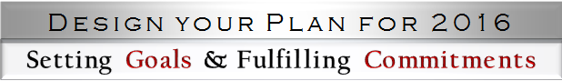

Part 3: In-session Workbook

Review your pre-session workbook and session notes. Highlight new knowledge and significant insights that fit with who you are and where you want to go. Reflect upon how you have been spending your time in both your work and your personal life.
- What should I continue? What continues to work well for me in my work and personal life?

- What can I stop doing – delegate or jettison? (or streamline, if necessary to keep)

- What can I start doing that can enhance my work and personal life?

- Who will my decisions impact besides me? (You will plan to follow up with them)

