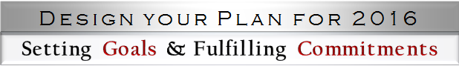

Part 1: Pre-session Workbook

1: Identifying My Values, Passions and Vision
- Values: What characteristics, qualities, and beliefs are at the core of who I am and how I live?
- Passions: What are my professional and personal passions? What cause motivates me to act? When am I compelled or convicted to take a stand? When am I enthusiastic about a project?
- Professional Vision: What vision can I imagine for my professional career in the future? What do I want to accomplish? Who do I aspire to be? What do I envision my legacy to be?
- Personal Vision: What vision can I imagine for my personal life in the future? What do I want to accomplish? Who do I aspire to be? What do I envision my legacy to be?

2: Acknowledging My Strengths and Addressing My Challenges

Strengths
- What qualities and attributes do I believe are my strengths?
- What do others appreciate about me?
- When am I in my element and achieving my goals?
- What are my gifts and talents?

Challenges
- What areas of my life do I find particularly challenging?
- What character qualities in myself would I like to improve?
- What do others think I need to work on?
- When do I feel frustrated?

3: Examining My Time Management Skills
Did I demonstrate good time management skills in the past year? Am I satisfied with how I allocated my time in terms of my professional life, personal life, and work-life integration? What went well? What suffered?

4: Evaluating My Prior Successes, Disappointments, and Revelations
- Which of the previous year’s professional and personal goals did I meet? What did I learn?
- What factors, resources, and individuals helped me reach those goals? (Consider paying this forward and sharing your experiences to help others. Thank those who assisted you.)
- What reasons can I identify for not reaching any of these goals? (e.g. need for further development, too many goals, revised my goals, time management, lack of resources, special circumstances or life factors, etc.)

Part 2 of this workbook will be provided in our “Design your Plan for 2016” workshop, in which you will:
- Learn to write “SMART” goals
- Determine what to “stop” and what to “start” in 2016
- Choose some time management strategies to optimize time in 2016

